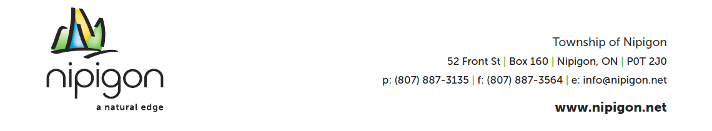
January 8, 2026

Township of Nipigon Residents
Re: Water System Update

Dear Sir/Madam,

The Municipality advises that the previously identified watermain leak within the distribution system has been successfully located and repaired. Public Works staff have confirmed that the repair is complete and the water distribution system has stabilized.

UPDATE ON SERVICE IMPACTS

As a result of the completed repair, residents will not experience any further temporary water shut offs or daytime water pressure interruptions related to this issue. All previously impacted areas, including First Street & Newton Street, have returned to normal service levels.

WATER CONSERVATION NOTICE – RESCINDED

The previously requested water conservation measures are no longer required. Reservoir levels and system pressure have returned to normal, and residents may resume normal water use.

BOIL WATER ADVISORY – REMAINS IN EFFECT

Please note that Zone A and Zone B (see map attached) remain under a Boil Water Advisory until further notice. This advisory continues to apply to all properties within Zone A & B, regardless of whether service interruptions were experienced.

The Boil Water Advisory will remain in place while required sampling, testing, and verification are completed in accordance with regulatory requirements. Residents will be notified immediately once the advisory is lifted.

Municipal staff will continue to closely monitor the system to ensure ongoing stability and water quality.

We appreciate your patience and cooperation throughout this process. Further updates will be provided as information becomes available. If you have any questions or require special accommodations, please contact the undersigned.

Yours very truly,

Taylor Haskell, C. Tech
Public Works Superintendent
Office: 807-887-3135 ext 204
pws@nipigon.net
Township of Nipigon

