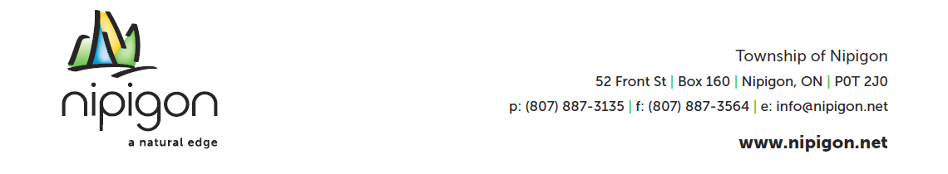

THE CORPORATION OF THE TOWNSHIP OF NIPIGON
JOB POSTING
PUBLIC WORKS DEPARTMENT
CASUAL PERMANENT LANDFILL ATTENDANT

The Township of Nipigon is an inclusive and diverse employer accepting applications for the position of Casual Permanent Landfill Attendant in our Public Works Department.
Responsibilities include, but are not limited to:
- Exercise good public relations at all times
- Open and close the access gates at the landfill site in accordance with the Hours of Operation, ensuring that all gates are properly secured outside of the Hours of Operation
- Conduct routine inspections of the perimeter fences to identify any occurrence of unauthorized entry, damage or other problems
- Dispose of any unauthorized material dumped at the entrance gate or other similar locations, including any material dumped outside of the Hours of Operation
- Direct traffic flow at the landfill sites having regard to public safety and in accordance with direction of the public works foreman.
- Refuse dumping of any non-compliant materials
- Prevent the scavenging of waste, recyclable or product stewardship materials by facility users
- Maintain landfill attendant trailer on site in a clean condition which may include, collection and disposal of fugitive waste material and litter that escapes during the operation of the facilities, and winter maintenance such as shoveling snow, sweeping in and around the trailer.
- Other duties as assigned by the Public Works Foreman or the senior staff.
Qualifications / Skills:
- 1 – 2 years of General Laborer experience
- Competent at completing necessary documentation on a daily basis
- Good understanding of the regional Occupational Health and Safety requirements
- Strong work ethic and willingness to persevere through difficult weather conditions and challenging work site environments.

Interested applicants may submit resumes and cover letters until 4:30 pm on Friday, January 30^{th,} 2026 or until the position is filled.
Taylor Haskell
Public Works Superintendent
Municipal Office – 52 Front Street, Nipigon ON P0T2J0
Email: pws@nipigon.net
Please include “Landfill Attendant” in the subject line.
The Township of Nipigon would like to thank everyone who applies, however, only those selected for an interview will be contacted. Personal information of applicants is collected under the authority of the Municipal Act, 2002, S.O. 2001 c. 25, as amended.

