January 2026
S | M | T | W | T | F | S
 |  |  |  | 1 | 2 ️️ | 3
4 | 5 | 6 ️️ | 7 | 8 | 9 ️️ | 10
11 | 12 | 13️️ | 14 | 15 | 16️️ | 17
18 | 19 | 20️️ | 21 | 22 | 23️️ | 24
25 | 26 | 27️️ | 28 | 29 | 30️️ | 31

February 2026
S | M | T | W | T | F | S
1 | 2 | 3 ️️ | 4 | 5 | 6 ️️ | 7
8 | 9 | 10️️ | 11 | 12 | 13️️ | 14
15 | 16 | 17️️ | 18 | 19 | 20️️ | 21
22 | 23 | 24️️ | 25 | 26 | 27️️ | 28

March 2026
S | M | T | W | T | F | S
1 | 2 | 3 ️️ | 4 | 5 | 6 ️️ | 7
8 | 9 | 10️️ | 11 | 12 | 13️️ | 14
15 | 16 | 17️️ | 18 | 19 | 20️️ | 21
22 | 23 | 24️️ | 25 | 26 | 27️️ | 28
29 | 30 | 31️️

April 2026
S | M | T | W | T | F | S
 |  |  | 1 | 2️  ️ | 3 | 4
5 | 6 | 7 ️️ | 8 | 9 | 10️️ | 11
12 | 13 | 14️️ | 15 | 16 | 17️️ | 18
19 | 20 | 21️️ | 22 | 23 | 24️️ | 25
26 | 27 | 28️️ | 29 | 30

May 2026
S | M | T | W | T | F | S
 |  |  |  |  | 1 ️️ | 2
3 | 4 | 5 ️️ | 6 | 7 | 8 ️️ | 9
10 | 11 | 12️️ | 13 | 14 | 15️️ | 16
17 | 18 | 19️️ | 20 | 21 | 22️️ | 23
24 | 25 | 26️️ | 27 | 28 | 29️️ | 30
31
June 2026
S | M | T | W | T | F | S
 | 1 | 2 ️️ | 3 | 4 | 5 ️️ | 6
7 | 8 | 9 ️️ | 10 | 11 | 12️️ | 13
14 | 15 | 16️️ | 17 | 18 | 19️️ | 20
21 | 22 | 23️️ | 24 | 25 | 26️️ | 27
28 | 29 | 30️️

July 2026
S | M | T | W | T | F | S
 |  |  | 1 | 2 | 3 ️️ | 4
5 | 6 | 7 ️️ | 8 | 9 | 10️️ | 11
12 | 13 | 14️️ | 15 | 16 | 17️️ | 18
19 | 20 | 21️️ | 22 | 23 | 24️️ | 25
26 | 27 | 28️️ | 29 | 30 | 31️️

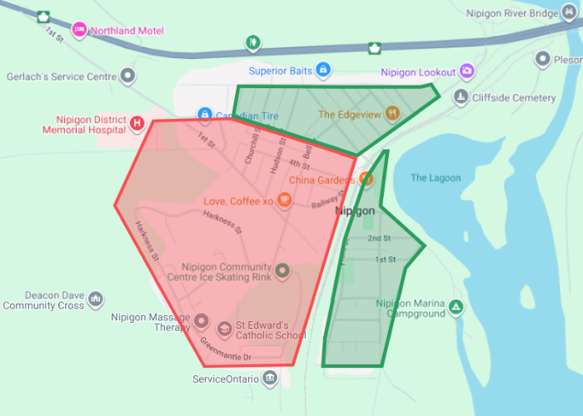
August 2026
S | M | T | W | T | F | S
 |  |  |  |  |  | 1
2 | 3 | 4 ️️ | 5 | 6 | 7 ️️ | 8
9 | 10 | 11️️ | 12 | 13 | 14️️ | 15
16 | 17 | 18️️ | 19 | 20 | 21️️ | 22
23 | 24 | 25️️ | 26 | 27 | 28️️ | 29
30 | 31

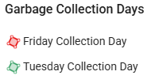
September 2026
S | M | T | W | T | F | S
 |  | 1 ️️ | 2 | 3 | 4 ️️ | 5
6 | 7 | 8 ️️ | 9 | 10 | 11️️ | 12
13 | 14 | 15️️ | 16 | 17 | 18️️ | 19
20 | 21 | 22️️ | 23 | 24 | 25️️ | 26
27 | 28 | 29️️ | 30

October 2026
S | M | T | W | T | F | S
 |  |  |  | 1 | 2 ️️ | 3
4 | 5 | 6 ️️ | 7 | 8 | 9 ️️ | 10
11 | 12 | 13️️ | 14 | 15 | 16️️ | 17
18 | 19 | 20️️ | 21 | 22 | 23️️ | 24
25 | 26 | 27️️ | 28 | 29 | 30️️ | 31


November 2026
S | M | T | W | T | F | S
1 | 2 | 3 ️️ | 4 | 5 | 6 ️️ | 7
8 | 9 | 10️️ | 11 | 12 | 13️️ | 14
15 | 16 | 17️️ | 18 | 19 | 20️️ | 21
22 | 23 | 24️️ | 25 | 26 | 27️️ | 28
29 | 30

December 2026
S | M | T | W | T | F | S
 |  | 1 ️️ | 2 | 3 | 4️️ | 5
6 | 7 | 8 ️️ | 9 | 10 | 11️️ | 12
13 | 14 | 15️️ | 16 | 17 | 18️️ | 19
20 | 21 | 22️️ | 23 | 24️  ️ | 25 | 26
27 | 28 | 29️️ | 30 | 31️  ️ | Jan 1, 2027

LEGEND
️️ | Garbage & Recycle Collection Dates
123 | Spring & Fall Cleanup Dates
123 | Landfill Site Closure-Stat Holidays
️ | Garbage Collection Date Change
Landfill Hours
Winter Hours:
*First Sunday in November-Second Sunday in March*
Monday: 12:00pm-5:00pm
Tuesday: 12:00pm-4:00pm
Friday: 12:00pm-5:00pm
Saturday: 12:00pm-4:00pm
Summer Hours:
*Second Sunday in March-First Sunday in November*
Monday: 2:00pm-7:00pm
Tuesday: 12:00pm-4:00pm
Friday: 2:00pm-7:00pm
Saturday: 12:00pm-4:00pm



Landfill Site Stat Holiday Closures 2026
Family Day (Monday February 16, 2026)
Good Friday (Friday April 3, 2026)
Easter Monday (Monday April 6, 2026)
Victoria Day (Monday May 18, 2026)
Civic Holiday (Monday August 3, 2026)
Labour Day (Monday September 7, 2026)
Thanksgiving Day (Monday October 12, 2026)
Christmas Day (Friday December 25, 2026)
Boxing Day (Saturday December 26, 2026)

Reminders
Landfill Access Cards:
Residents are reminded to pick up their landfill access cards at the Municipal Office, should you be unable to pick up your card please contact the front reception at info@nipigon.net or 807-887-3135 to request an accommodation.
Hazardous Waste Day:
Hazardous Waste Day’s occur every other calendar year, the next scheduled event is in Spring/Summer 2027.

Spring & Fall Clean Up
Spring Cleanup:
May 19, 22, 26 & 29, 2026
All materials must be in compact bundles weighing not more than 50 (fifty) pounds in weight. Branches must be no longer than 4 feet, items will be picked up by the Public Works Crew on your respective garbage day and spring clean up waste is free of charge if delivered to landfill by owner.
Fall Cleanup:
October 19th to October 24th, 2026
Landfill site tipping fees are waived during the time frame mentioned above if delivered by the property owner. Pick up is not available.

